Docker Task -01
1. Setup a virtual machine using Ubuntu image.
Step 1. Open EC2
- Log in to the AWS Management Console.
- Go to EC2.
- Select Instances → Launch instances.

2. Configure the virtual machine
Name:
- Give a name such as Ubuntu-machine.
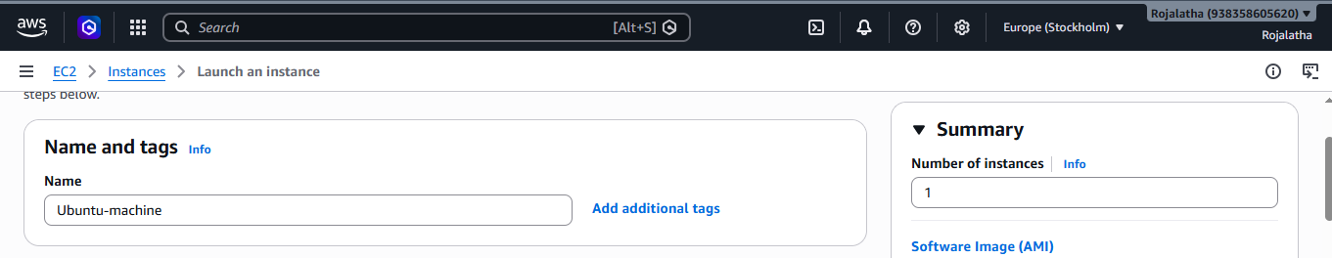
Application and OS Images (AMI):
- Select Ubuntu.
- Choose an Ubuntu Server LTS image.
- Architecture: 64-bit (x86) unless your assignment specifies ARM.
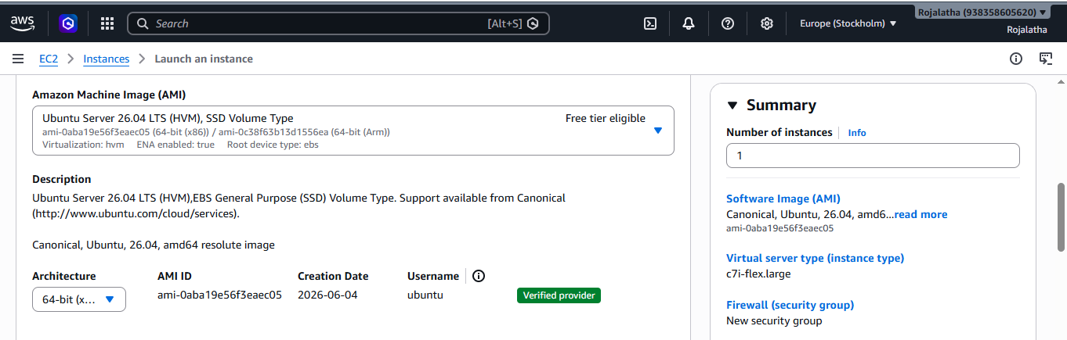

Instance type:
- For practice, you can use C7-flex.large or an eligible free-tier instance type available in your account/region.
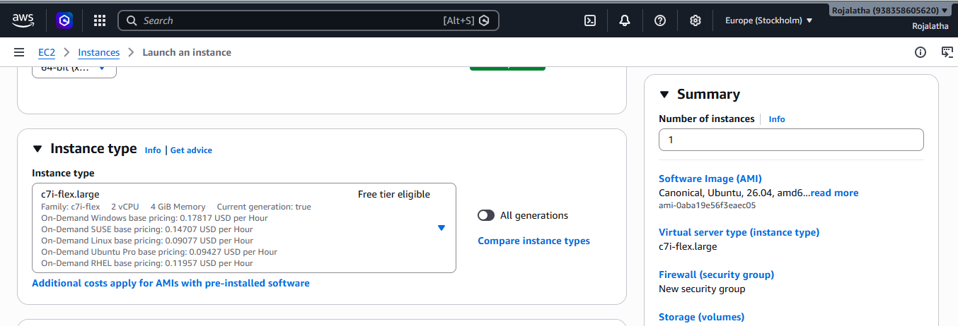
Key pair:
- Create a new key pair or select an existing one.
- Download the .pem file and keep it safe. You need it to connect through SSH.
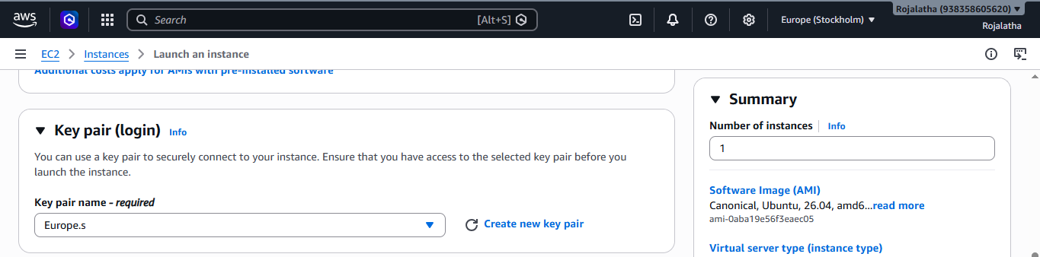
Network Settings
Under Network settings, select or create a VPC and subnet.
• Enable Auto-assign public IP if you need to connect to the VM from the internet.
• Under Firewall/Security Group, allow:
- SSH (TCP 22) — preferably only from My IP.
- HTTP (TCP 80) if you plan to host a website.
- HTTPS (TCP 443) if you plan to host a secure website.
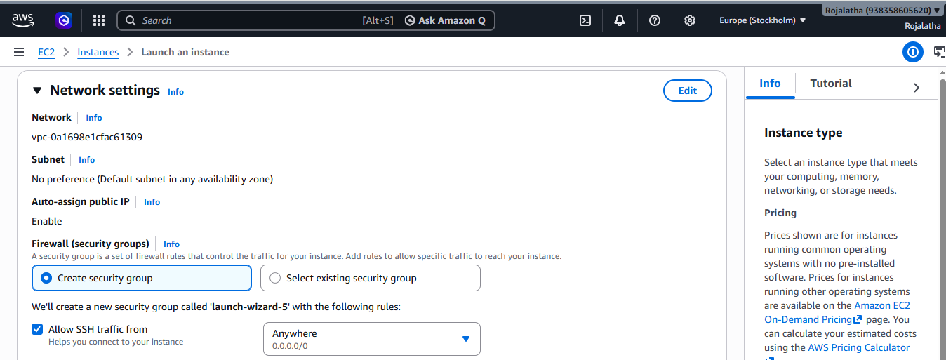
Configure Storage
Select the storage of 20 gb volume.
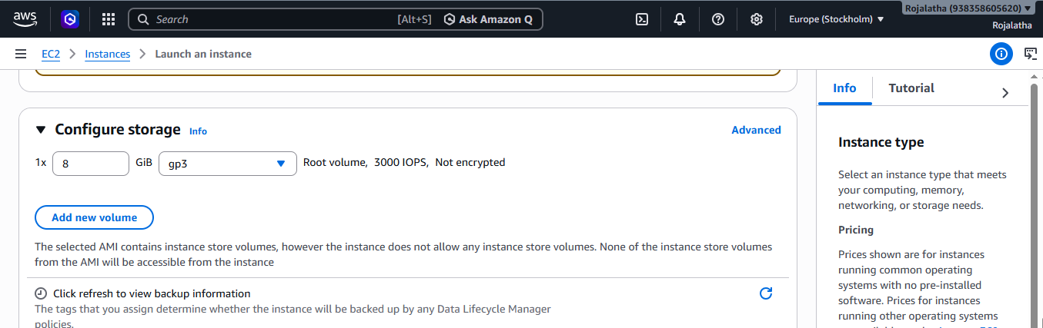

Launch the Instance
• Review the configuration on the right side.
• Click Launch instance.
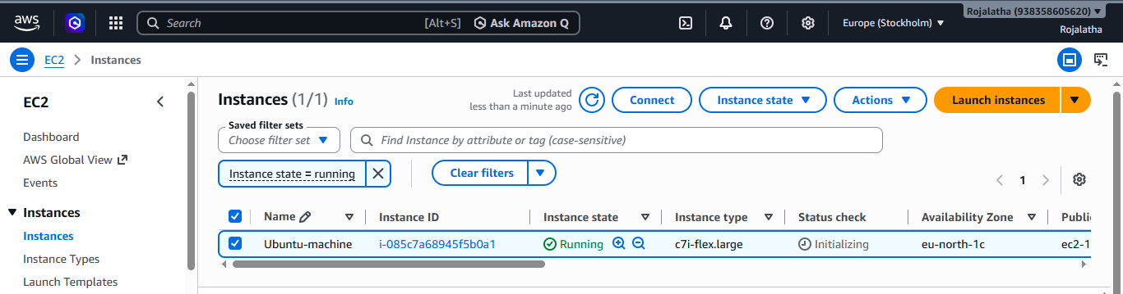

2. Install docker on ec2.

Step 1: Update Ubuntu
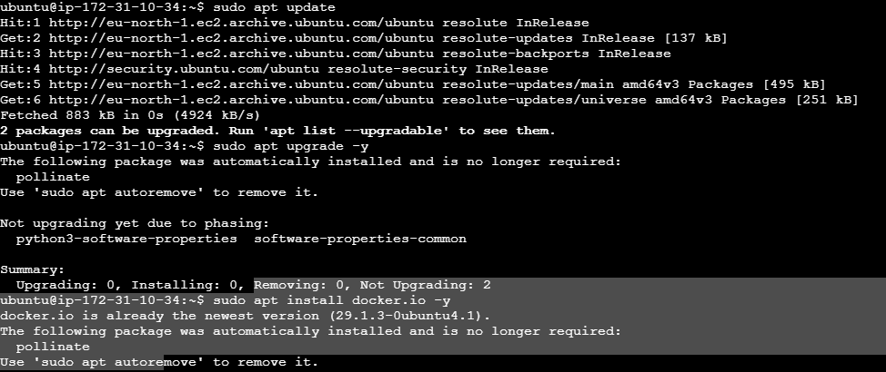
Step 2: Install Docker
Start, enable docker and verify docker version
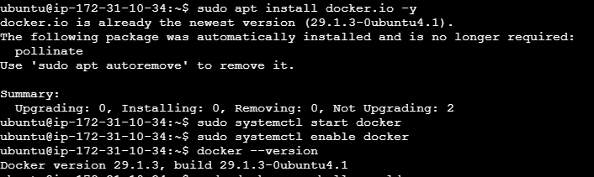
Tested Docker:
By running the command sudo docker run hello-world was able to see "Hello from Docker!" message and Verified Docker is working correctly.
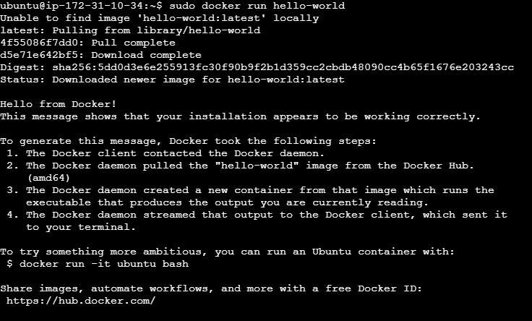

3. Pull 5 docker images. (nginx, Apache tomcat, ubuntu, Jenkins, SonarQube)

Step 1: Pull Nginx image
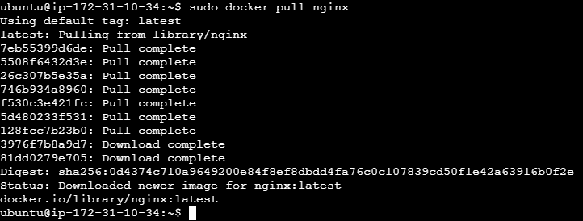

Step 2: Pull Apache Tomcat image
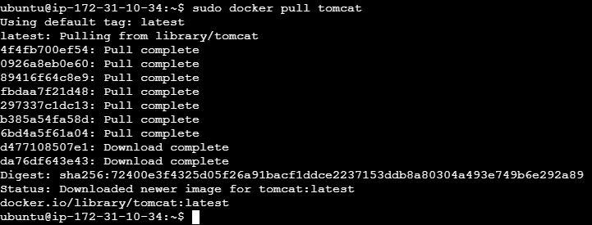

Step 3: Pull Ubuntu image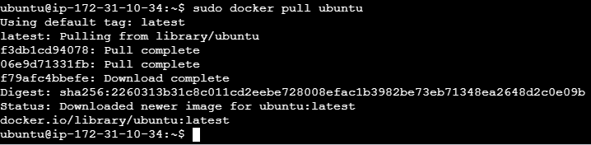

Step 4: Pull Jenkins image
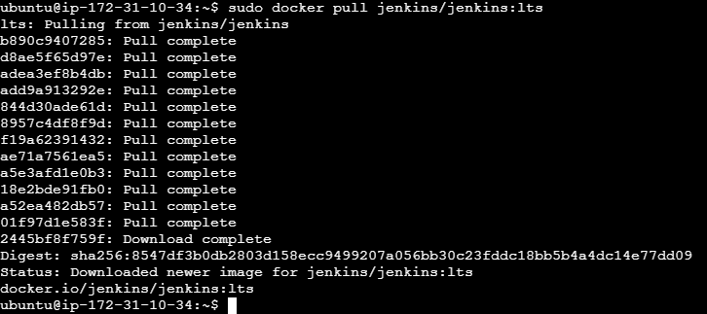

Step 5: Pull Sonarqube image
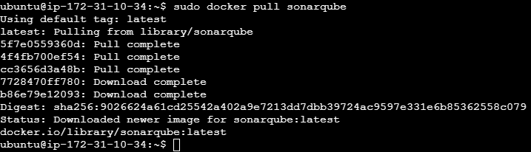
Step 6: Verified the pulled images using the command sudo docker images:
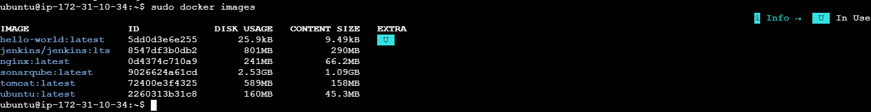
4. Run nginx container and expose on port 81.

Step 1: Run the Nginx container and check whether container is running:

Step 2: Allow port 81 in AWS Security Group
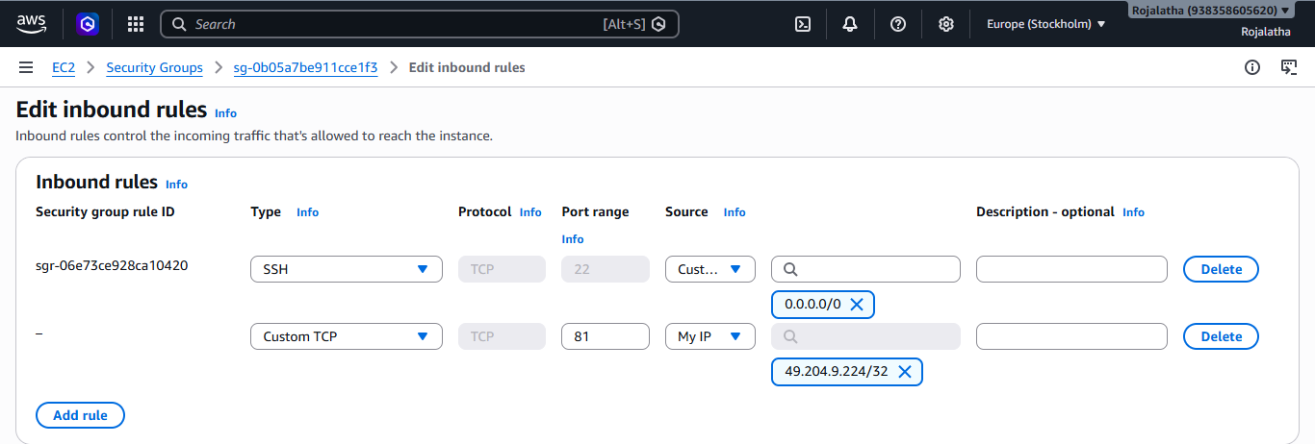
Step 3: Test Nginx
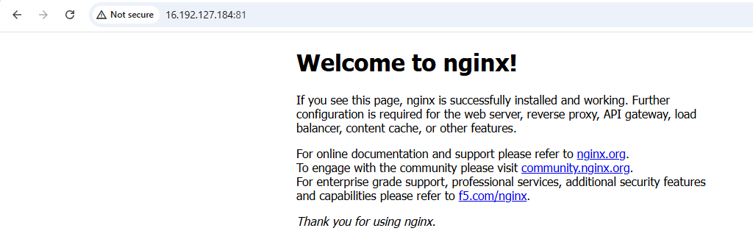
Step 4: Verify from the EC2 terminal
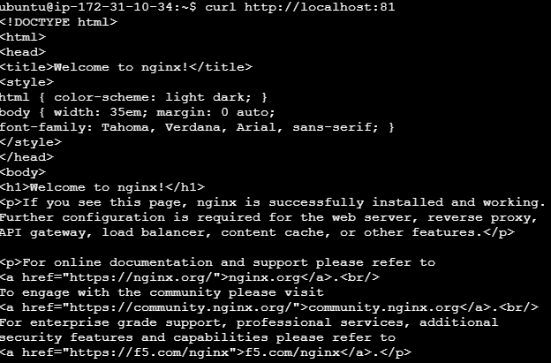
5. Delete the Apache tomcat image from local.
Step 1: Remove the Tomcat image

Step 2: Verify deletion
After Deleting the tomcat image it is not listed in the docker images
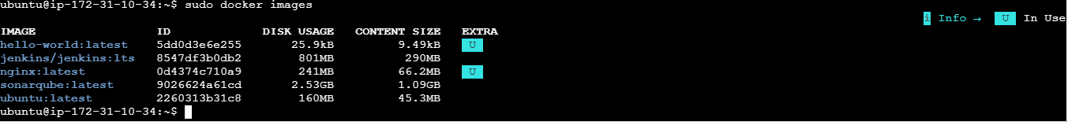

6. Inspect the Jenkins image, SonarQube image.
Step 1: Inspect the Jenkins image
This displays detailed information about the Jenkins image, including:
- Image ID
- Created date
- Architecture
- OS
- Environment variables
- Exposed ports
- Volumes
- Entrypoint
- Docker configuration
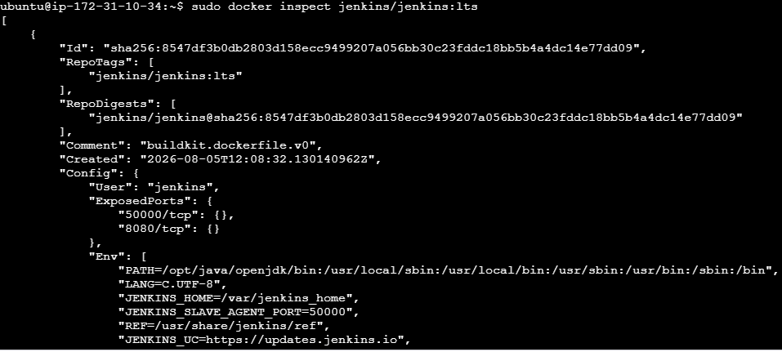

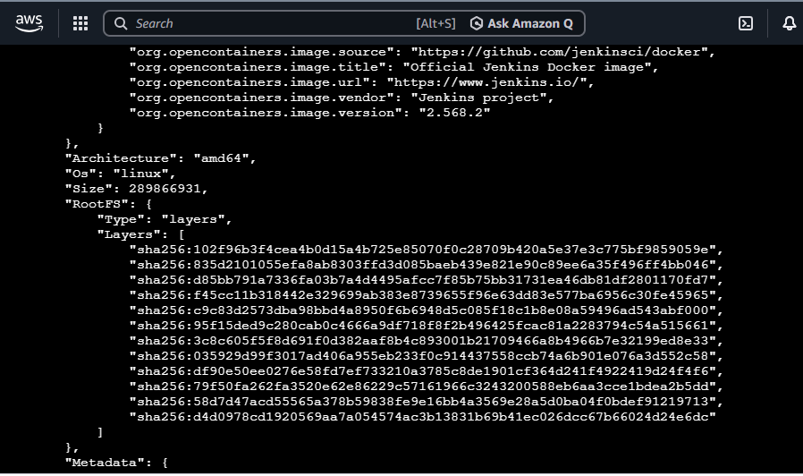
Step 2: Inspect the SonarQube image
This displays the same type of detailed information for the SonarQube image.
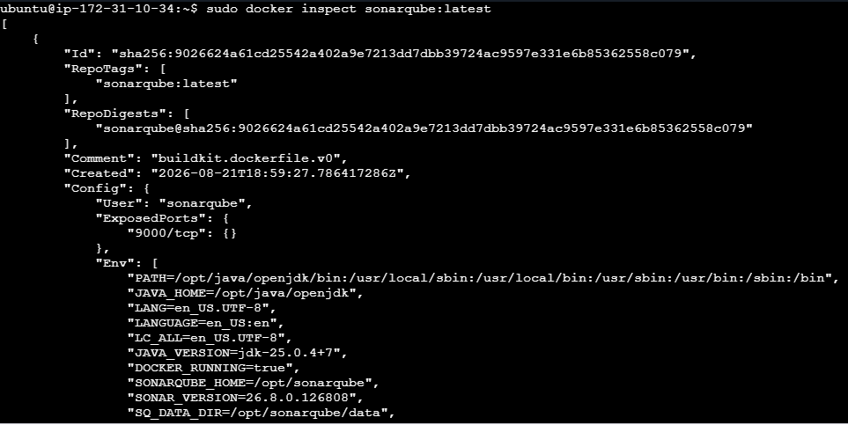
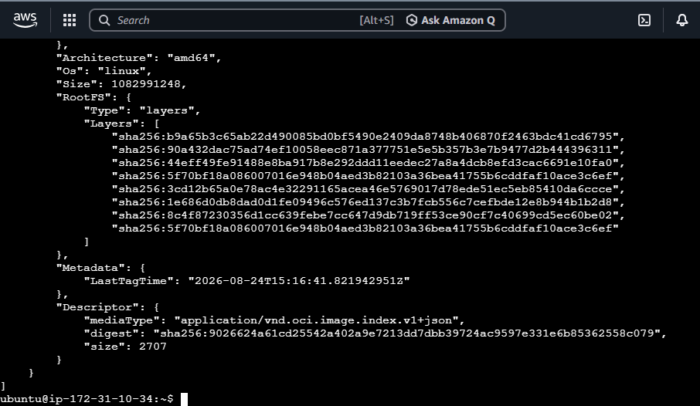

7. Run Jenkins container and run one sample job.
Step 1: Run the Jenkins container

Step 2: Check the container
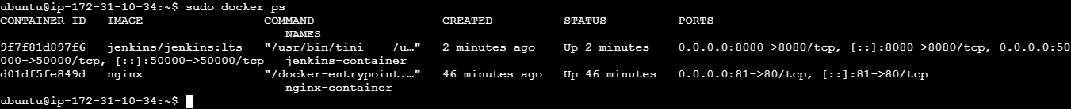

Step 3: Get the Jenkins initial password
Copy the password

Step 4: Allow port 8080 in AWS

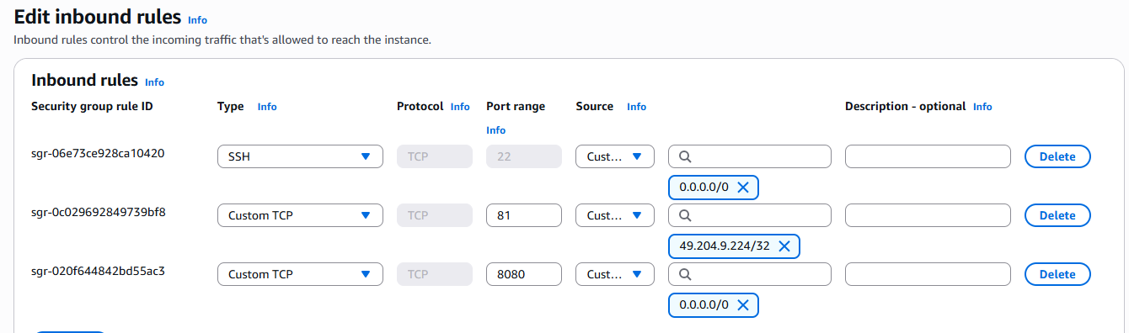
Step 5: Open Jenkins
Find your EC2 instance's Public IPv4 address.
Open this in your browser: http://YOUR_EC2_PUBLIC_IP:8080
For example: http://13.xxx.xxx.xxx:8080 and paste the copied initial password to see the below page.
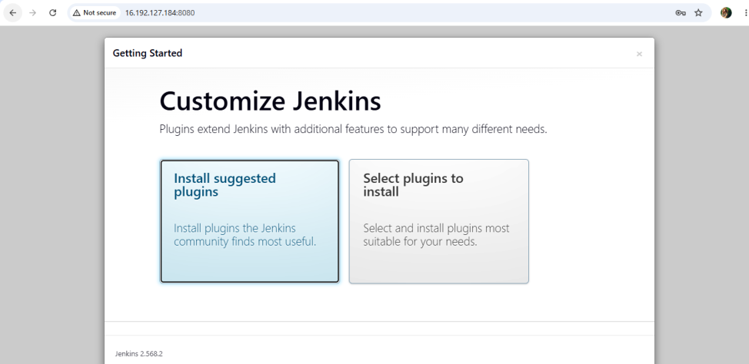

Step 6: Complete Jenkins setup
• Select Install suggested plugins.
• Wait for the plugins to install.
• Create your Jenkins administrator account.
• Complete the setup.
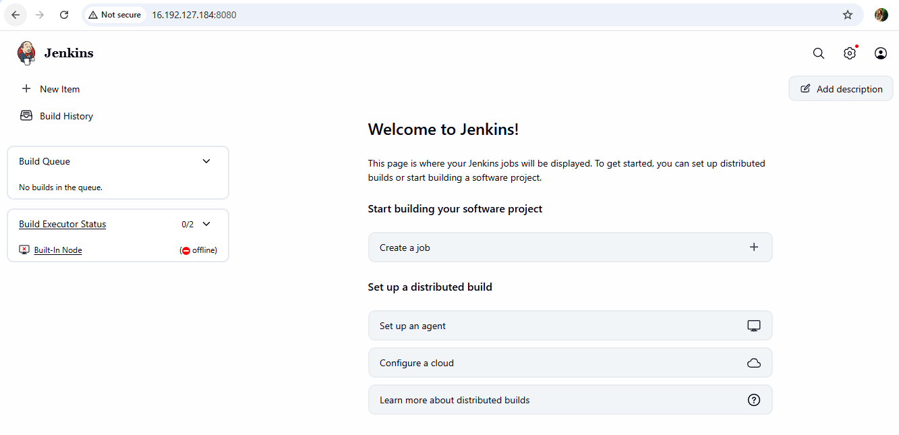

Step 7: Create a sample job
From the Jenkins dashboard:
- Click New Item.
- Enter a name, for example: Sample-Job
- Select Freestyle project.
- Click OK.
- Scroll down to Build Steps.
- Click Add build step → Execute shell.
- Enter: echo "Hello from Jenkins!"
echo "Jenkins sample job executed successfully."
Click Save and Click Build Now

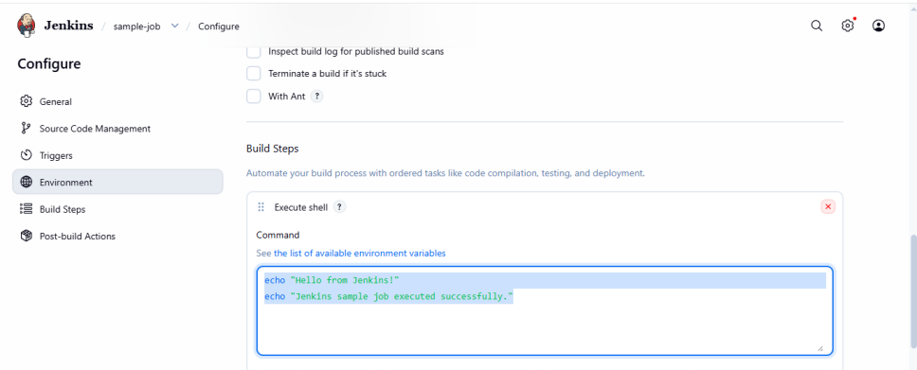
Step 8: Verify the job
Open sample-job → Build #1 → Console Output.
